**IDS 462 STATISTICAL SOFTWARE FOR BUSINESS**

**HOMEWORK 2 – Part 2**

**TEAM MEMBERS**:

1. Harish Visweswaraiya
2. Balachandhar Chekka Narayanasame
3. Sriram Ravi
4. Vinodh Sankaran

**Problem**

**Attached CSV and TXT files contain female and male customers of a club.**

**Data fields are:**

cust_ID numeric

County 2 characters

First Name 15 characters

Last Name 20 characters

Birth Date

Customer_Type 40 characters

**Create a temporary SAS dataset using data steps for each gender type and find the count of female & male customers in Country by Customer type.**

**Code – CSV file**

data female_cust;

infile '/folders/myfolders/SAS_HW2/customers_female.csv' DLM=',' DSD MISSOVER FIRSTOBS=1;

input cust_ID

county :$2.

first_name :$15.

last_name :$20.

birth_date :mmddyy.

customer_type :$40.;

format birth_date mmddyy10.;

Run;

proc freq data=female_cust;

tables customer_type/out=female_count norow nocol nopercent nocum;

run;

**Output Data**

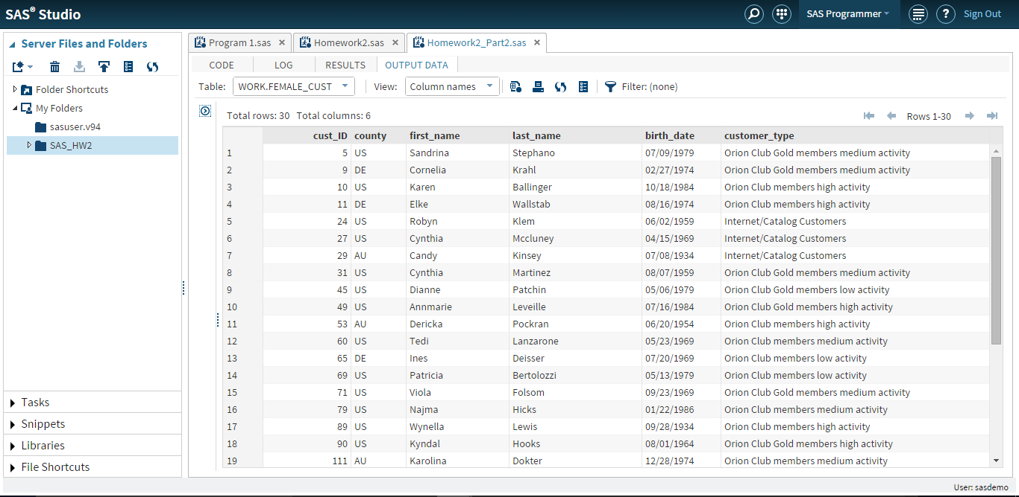

**Count based on customer type**

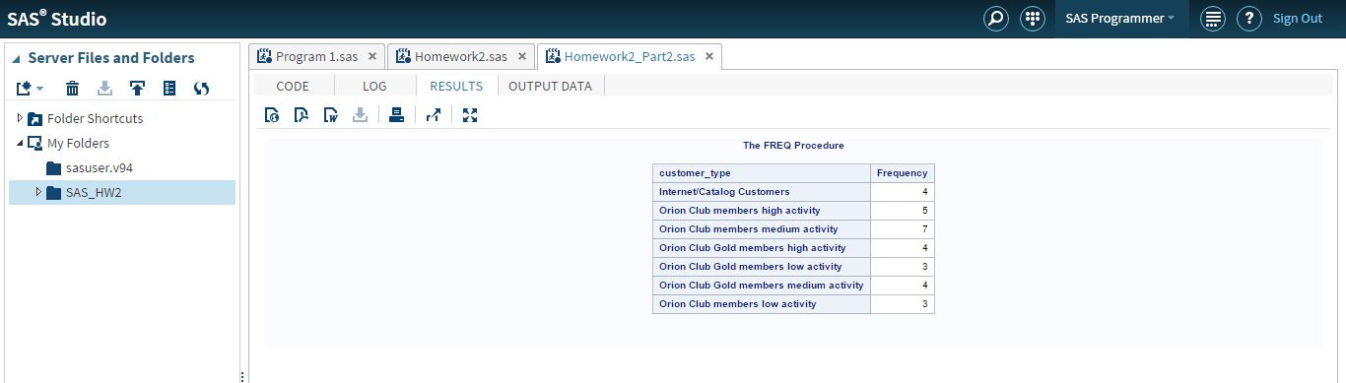

**Code – TXT file**

data male_cust;

infile '/folders/myfolders/SAS_HW2/customers_male.txt' DLM='09'x DSD MISSOVER FIRSTOBS=1;

input cust_ID

county :$2.

first_name :$15.

last_name :$20.

birth_date :mmddyy.

customer_type :$40.;

format birth_date mmddyy10.;

Run;

proc freq data=male_cust;

tables customer_type/out=male_count norow nocol nopercent nocum;

run;

**Output Data**

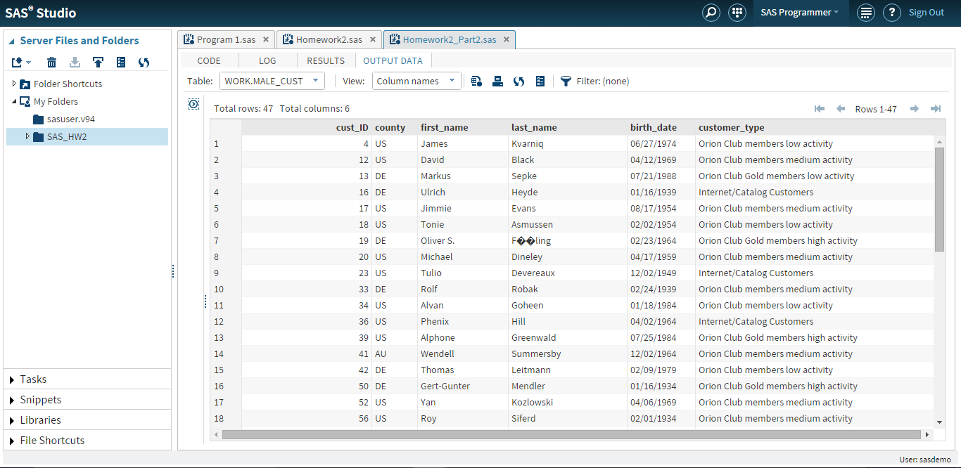

**Count based on customer type**